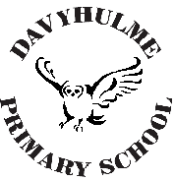

Reaching for the Stars!

Dear Parents/Carers,

PARENTS’ EVENING

We are delighted to inform you that parent/teacher meetings will be face-to-face this time. We are offering a choice of two evenings to discuss your child’s progress and attainment with their teacher – Tuesday 7th and Wednesday 8th November 2023 between 3.30pm and 6.30pm. As time is limited, we aim to give parents a five-minute slot to discuss these issues; if extra time is needed then your child’s class teacher will arrange a longer appointment at a later date.

Please note that appointments are strictly for these two dates only, unless in exceptional circumstances. This is to ensure that we protect our staff’s work/life balance.

Appointments for these face-to-face meetings can be booked online using School Cloud, please copy and paste the following link (https://davyhulme.schoolcloud.co.uk) from Monday 16th October at 9am until Monday 6th November at 3.30pm. We would like to respectfully remind parents and carers that it is your responsibility to make these appointments: it is not the responsibility of office staff or the class teacher. Please ensure you can log onto your School Cloud account before the system goes live and should you have any problems please contact the school office.

Yours sincerely,

Mr P McDowell
Headteacher

